[TC-1] arithmetic operation is executed with correct result Created: 12/Jan/22 Updated: 12/Jan/22 Due: 12/Jan/22
Status: | To Do
Project: | Testing_Calculator
Components: | None

Type: | Bug | Priority: | High
Reporter: | sergey poliakov | Assignee: | Unassigned

Attachments: | 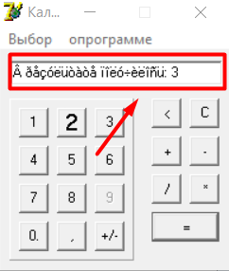
Severity: | Critical
Sprint: | Доска Спринт 1
ID: | 01
Summary: | Verify that simple arithmetic operation is executed with correct result
Status: | Assigned
Application: | Desktop
Environment: | Prod
Reproducibility: | Always

Description

Calculator should be running
Steps to reproduce:
- Select number 1 than click “plus” select number 2 and click “equals”
Actual Result:
Correct result is shown with wrong encoding message
Expected Result:
Should be shown correct result

Generated at Wed Jan 12 07:28:58 UTC 2022 by sergey poliakov using Jira 1001.0.0-SNAPSHOT#100188-sha1:6a5f66478994ab49804b38702d6ff034782551fa.

[TC-2] Verify that engineering calculator is available Created: 12/Jan/22 Updated: 12/Jan/22 Due: 12/Jan/22
Status: | To Do
Project: | Testing_Calculator
Components: | None

Type: | Bug | Priority: | High
Reporter: | sergey poliakov | Assignee: | Unassigned

Attachments: | 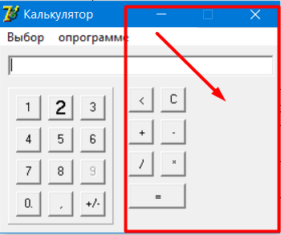
Severity: | Critical
Sprint: | Доска Спринт 1
ID: | 02
Summary: | Switching the functionality of the application
Status: | Assigned
Application: | Desktop
Environment: | Prod
Reproducibility: | Always

Description

Calculator should be running
Steps to reproduce:
- Click on menu item “Выбор” and choose from Combo-box “Инженерный”
Actual Result:
At the right side displayed empty work area
Expected Result:
Should be shown at the right side engineering calculator

Generated at Wed Jan 12 07:29:03 UTC 2022 by sergey poliakov using Jira 1001.0.0-SNAPSHOT#100188-sha1:6a5f66478994ab49804b38702d6ff034782551fa.

[TC-3] engineering calculator is available Created: 12/Jan/22 Updated: 12/Jan/22 Due: 12/Jan/22
Status: | To Do
Project: | Testing_Calculator
Components: | None

Type: | Bug | Priority: | Low
Reporter: | sergey poliakov | Assignee: | Unassigned

Attachments: | 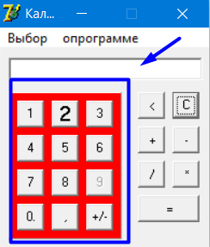
Severity: | Minor
Sprint: | Доска Спринт 1
ID: | 03
Summary: | Switching the functionality of the application from “Инженерный” to “Обычный”
Status: | Assigned
Application: | Desktop
Environment: | Prod
Reproducibility: | Always

Description

Calculator should be running
Steps to reproduce:
- Click on menu item “Выбор” and choose from Combo-box “Инженерный”
Actual Result:
At the right side displayed empty work area
Expected Result:
Should be shown at the right side engineering calculator

Generated at Wed Jan 12 07:29:10 UTC 2022 by sergey poliakov using Jira 1001.0.0-SNAPSHOT#100188-sha1:6a5f66478994ab49804b38702d6ff034782551fa.

[TC-4] Verify that the font meets the requirements Created: 12/Jan/22 Updated: 12/Jan/22 Due: 12/Jan/22
Status: | To Do
Project: | Testing_Calculator
Components: | None

Type: | Bug | Priority: | Low
Reporter: | sergey poliakov | Assignee: | Unassigned

Attachments: | 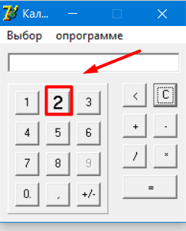
Severity: | Minor
Sprint: | Доска Спринт 1
ID: | 04
Summary: | Verify that the font meets the requirements
Status: | Assigned
Application: | Desktop
Environment: | Prod
Reproducibility: | Always

Description

Calculator should be running
Steps to reproduce:
- Pay attention to the number 2
Actual Result:
Number 2 had bigger size than normal and had cursive
Expected Result:
Number 2 should not be big size and has cursive

Generated at Wed Jan 12 07:37:27 UTC 2022 by sergey poliakov using Jira 1001.0.0-SNAPSHOT#100188-sha1:6a5f66478994ab49804b38702d6ff034782551fa.

[TC-5] Verify that menu item is available Created: 12/Jan/22 Updated: 12/Jan/22 Due: 12/Jan/22
Status: | To Do
Project: | Testing_Calculator
Components: | None

Type: | Bug | Priority: | Low
Reporter: | sergey poliakov | Assignee: | Unassigned

Attachments: | 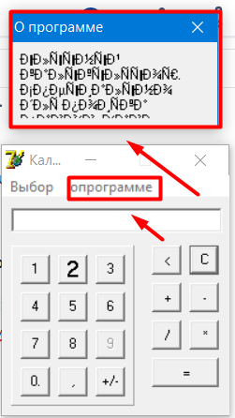
Severity: | Minor
Sprint: | Доска Спринт 1
ID: | 05
Summary: | Verify that menu item is available
Status: | Assigned
Application: | Desktop
Environment: | Prod
Reproducibility: | Always

Description

Calculator should be running
Steps to reproduce:
- Pay attention to the menu item “опрограмме”
Actual Result:
menu item “опрограмме” is misspelled
Expected Result:
menu item “опрограмме” should be written correctness

Generated at Wed Jan 12 07:38:50 UTC 2022 by sergey poliakov using Jira 1001.0.0-SNAPSHOT#100188-sha1:6a5f66478994ab49804b38702d6ff034782551fa.

[TC-6] Verify that all number is available Created: 12/Jan/22 Updated: 12/Jan/22 Due: 12/Jan/22
Status: | To Do
Project: | Testing_Calculator
Components: | None

Type: | Bug | Priority: | High
Reporter: | sergey poliakov | Assignee: | Unassigned

Attachments: | 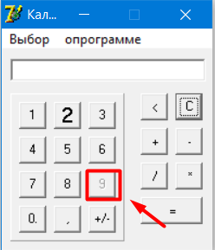
Severity: | Critical
Sprint: | Доска Спринт 1
ID: | 06
Summary: | Verify that all number is available
Status: | Assigned
Application: | Desktop
Environment: | Prod
Reproducibility: | Always

Description

Calculator should be running
Steps to reproduce:
- Click on number 9
Actual Result:
Number 9 should is blocked
Expected Result:
Number 9 should be available

Generated at Wed Jan 12 07:40:07 UTC 2022 by sergey poliakov using Jira 1001.0.0-SNAPSHOT#100188-sha1:6a5f66478994ab49804b38702d6ff034782551fa.

[TC-7] Verify that user is able to divide by 0 Created: 12/Jan/22 Updated: 12/Jan/22 Due: 12/Jan/22
Status: | To Do
Project: | Testing_Calculator
Components: | None

Type: | Bug | Priority: | Low
Reporter: | sergey poliakov | Assignee: | Unassigned

Attachments: | 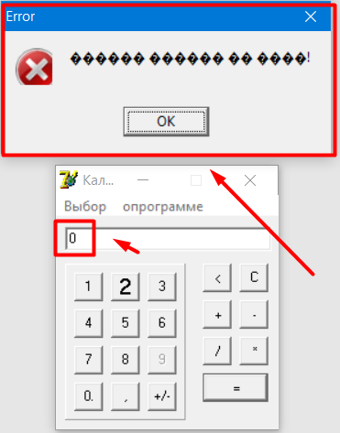
Severity: | Minor
Sprint: | Доска Спринт 1
ID: | 07
Summary: | Verify that user is able to divide by 0
Status: | Assigned
Application: | Desktop
Environment: | Prod
Reproducibility: | Always

Description

Calculator should be running
Steps to reproduce:
- Select available number and click “divide” than select 0 and click “equals”
Actual Result:
Error message is shown with wrong encoding
Expected Result:
Error message should be shown with correct text display

Generated at Wed Jan 12 07:40:52 UTC 2022 by sergey poliakov using Jira 1001.0.0-SNAPSHOT#100188-sha1:6a5f66478994ab49804b38702d6ff034782551fa.

[TC-8] Verify that user is able to make any arithmetic operations with float number Created: 12/Jan/22 Updated: 12/Jan/22 Due: 12/Jan/22
Status: | To Do
Project: | Testing_Calculator
Components: | None

Type: | Bug | Priority: | High
Reporter: | sergey poliakov | Assignee: | Unassigned

Attachments: | 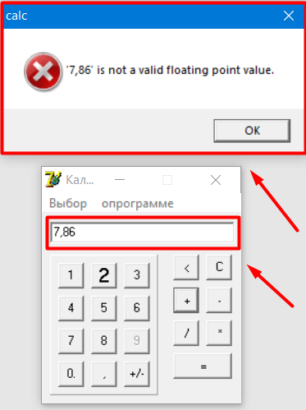
Severity: | Critical
Sprint: | Доска Спринт 1
ID: | 08
Summary: | Verify that user is able to make any arithmetic operations with float number
Status: | Assigned
Application: | Desktop
Environment: | Prod
Reproducibility: | Always

Description

Description
Calculator should be running
Steps to reproduce:
- Select available number and click “dot” than select available number and click “equals”
Actual Result:
Error message is shown “is not available floating point value”
Expected Result:
Should be shown correct result

Generated at Wed Jan 12 07:41:43 UTC 2022 by sergey poliakov using Jira 1001.0.0-SNAPSHOT#100188-sha1:6a5f66478994ab49804b38702d6ff034782551fa.

[TC-9] Verify that arithmetic operations with integer number should not begin with 0 Created: 12/Jan/22 Updated: 12/Jan/22 Due: 12/Jan/22
Status: | To Do
Project: | Testing_Calculator
Components: | None

Type: | Bug | Priority: | High
Reporter: | sergey poliakov | Assignee: | Unassigned

Attachments: | 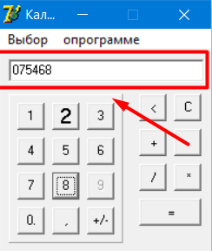
Severity: | Critical
Sprint: | Доска Спринт 1
ID: | 09
Summary: | Verify that arithmetic operations with integer number should not begin with 0
Status: | Assigned
Application: | Desktop
Environment: | Prod
Reproducibility: | Always

Description

Calculator should be running
Steps to reproduce:
- Select first number 0 than select any available number and click any arithmetic operation than select available number and click “equals”
Actual Result:
Executed arithmetic operation with incorrect result
Expected Result:
Should not be executed any arithmetic operation

Generated at Wed Jan 12 07:43:09 UTC 2022 by sergey poliakov using Jira 1001.0.0-SNAPSHOT#100188-sha1:6a5f66478994ab49804b38702d6ff034782551fa.

[TC-10] The application is able to hangs when clicking on a non-functional work area Created: 12/Jan/22 Updated: 12/Jan/22 Due: 12/Jan/22
Status: | To Do
Project: | Testing_Calculator
Components: | None

Type: | Bug | Priority: | Highest
Reporter: | sergey poliakov | Assignee: | Unassigned

Attachments: | 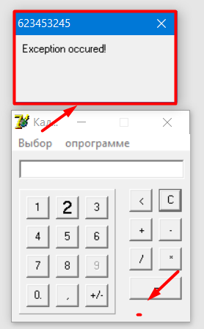
Severity: | Critical
Sprint: | Доска Спринт 1
ID: | 10
Summary: | The application is able to hangs when clicking on a non-functional work area
Status: | Assigned
Application: | Desktop
Environment: | Prod
Reproducibility: | Always

Description

Description
Calculator should be running
Steps to reproduce:
- Click on non-functional empty work area
Actual Result:
Application is crashed
Expected Result:
The application should be work stably

Generated at Wed Jan 12 07:44:14 UTC 2022 by sergey poliakov using Jira 1001.0.0-SNAPSHOT#100188-sha1:6a5f66478994ab49804b38702d6ff034782551fa.

[TC-11] Verify that user is able to execute any arithmetic operation with second number more than 100 Created: 12/Jan/22 Updated: 12/Jan/22 Due: 12/Jan/22
Status: | To Do
Project: | Testing_Calculator
Components: | None

Type: | Bug | Priority: | High
Reporter: | sergey poliakov | Assignee: | Unassigned

Attachments: | 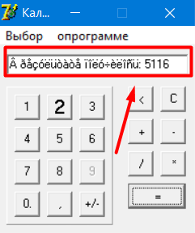
Severity: | Critical
Sprint: | Доска Спринт 1
ID: | 11
Summary: | Verify that user is able to execute any arithmetic operation with second number more than 100
Status: | Assigned
Application: | Desktop
Environment: | Prod
Reproducibility: | Always

Description

Calculator should be running
Steps to reproduce:
- Select first number “5000” than select arithmetic operation “plus” than select number “101” and click “equals”
Actual Result:
Wrong result 5116
Expected Result:
Should be shown correct result

Generated at Wed Jan 12 07:45:18 UTC 2022 by sergey poliakov using Jira 1001.0.0-SNAPSHOT#100188-sha1:6a5f66478994ab49804b38702d6ff034782551fa.

[TC-12] Impossible to get correct result when execute more than one arithmetic operation Created: 12/Jan/22 Updated: 12/Jan/22 Due: 12/Jan/22
Status: | To Do
Project: | Testing_Calculator
Components: | None

Type: | Bug | Priority: | High
Reporter: | sergey poliakov | Assignee: | Unassigned

Attachments: | 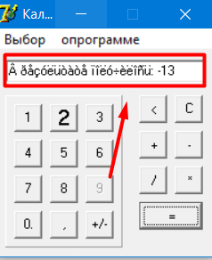
Severity: | Critical
Sprint: | Доска Спринт 1
ID: | 12
Summary: | Impossible to get correct result when execute more than one arithmetic operation
Status: | Assigned
Application: | Desktop
Environment: | Prod
Reproducibility: | Always

Description

Calculator should be running
Steps to reproduce:
- Execute first arithmetic operation: “12345+67”
2. Click “minus” and select number “80” and click “equals”
Actual Result:
Wrong result was shown -13
Expected Result:
Should be correct result

Generated at Wed Jan 12 07:46:17 UTC 2022 by sergey poliakov using Jira 1001.0.0-SNAPSHOT#100188-sha1:6a5f66478994ab49804b38702d6ff034782551fa.

[TC-13] Verify that actual result from past operation should be used for next arithmetic operation Created: 12/Jan/22 Updated: 12/Jan/22 Due: 12/Jan/22
Status: | To Do
Project: | Testing_Calculator
Components: | None

Type: | Bug | Priority: | High
Reporter: | sergey poliakov | Assignee: | Unassigned

Attachments: | 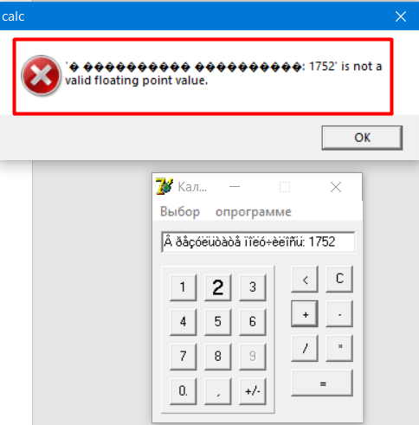
Severity: | Critical
Sprint: | Доска Спринт 1
ID: | 13
Summary: | Verify that actual result from past operation should be used for next arithmetic operation
Status: | Assigned
Application: | Desktop
Environment: | Prod
Reproducibility: | Always

Description

Calculator should be running
Steps to reproduce:
- Execute arithmetic operation: “876 multiply 2” and click “equals”
2. Use actual result and click for any arithmetic operation
Actual Result:
Wrong result
Expected Result:
Should be correct result

Generated at Wed Jan 12 07:47:32 UTC 2022 by sergey poliakov using Jira 1001.0.0-SNAPSHOT#100188-sha1:6a5f66478994ab49804b38702d6ff034782551fa.

[TC-14] Verify that user is able to input only numeric data Created: 12/Jan/22 Updated: 12/Jan/22 Due: 12/Jan/22
Status: | To Do
Project: | Testing_Calculator
Components: | None

Type: | Bug | Priority: | High
Reporter: | sergey poliakov | Assignee: | Unassigned

Attachments: | 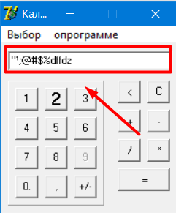
Severity: | Critical
Sprint: | Доска Спринт 1
ID: | 14
Summary: | Verify that user is able to input only numeric data
Status: | Assigned
Application: | Desktop
Environment: | Prod
Reproducibility: | Always

Description

Calculator should be running
Steps to reproduce:
- Click on “entry field” and add from the keyboard any letters or symbols
Actual Result:
Letters and symbols are added to the “entry field”
Expected Result:
Letters and symbols should not be added to the “entry field”

Generated at Wed Jan 12 07:48:58 UTC 2022 by sergey poliakov using Jira 1001.0.0-SNAPSHOT#100188-sha1:6a5f66478994ab49804b38702d6ff034782551fa.

[TC-15] On hover at number 8 is appeared Tool Tip with different symbols Created: 12/Jan/22 Updated: 12/Jan/22 Due: 12/Jan/22
Status: | To Do
Project: | Testing_Calculator
Components: | None

Type: | Bug | Priority: | Low
Reporter: | sergey poliakov | Assignee: | Unassigned

Attachments: | 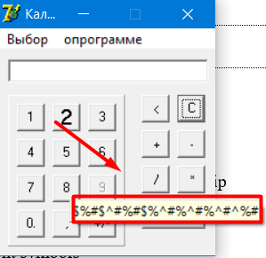
Severity: | Minor
Sprint: | Доска Спринт 1
ID: | 15
Summary: | On hover at number 8 is appeared Tool Tip with different symbols
Status: | Assigned
Application: | Desktop
Environment: | Prod
Reproducibility: | Always

Description

Calculator should be running
Steps to reproduce:
- Hover on cursor on number 8 and Pay attention to Tool Tip
Actual Result:
Tool Tip is shown with different symbols
Expected Result:
Should not be shown Tool Tip

Generated at Wed Jan 12 07:49:54 UTC 2022 by sergey poliakov using Jira 1001.0.0-SNAPSHOT#100188-sha1:6a5f66478994ab49804b38702d6ff034782551fa.

